Office of the Principal, Nilamani Mahavidyalaya, Rupsa, Balasore

Exam. Notice No.-133 Date: 17.10.23

+2-2nd Year Arts/ Sc. 2nd Internal Examination Notice-2023

It is hereby notified that as per CHSE Notification No.-3375, Dated-05.08.23 the 2nd Internal Examination of +2-2nd Year Arts and Science will be held as per the following programme. Students are informed to appear the said examination.
Date | 1st Sitting  Time-1 P.M. to 1.45 P.M. | 2nd sitting  Time-2.45 P.M. to 3.30 P.M.
03.11.23  Friday | +2-2nd Year Arts-M.I.L (O)  +2-2nd Year Science-M.I.L. (O) | +2-2nd Year Arts-English  +2-2nd Year Science-English
04.11.23  Saturday | +2-2nd Year Arts-Pol. Sc  + 2-2nd Year Science-Physics | +2-2nd Year Arts-History  +2-2nd Year Science-Chemistry
06.11.23  Monday | +2-2nd Year Arts-Education / T.T.M.  +2-2nd Year Science & Arts-Mathematics | +2-2nd Year Arts-Logic  +2-2nd Year Science-Botany
07.11.23  Tuesday | +2-2nd Year Arts-Sanskrit / Odia  +2-2nd Year Science - Zoology | +2-2nd Year Arts-Economics .

Practical/ Project Examinations of all the concerned subjects must be conducted between 08.11.23 to 15.11.23 positively.

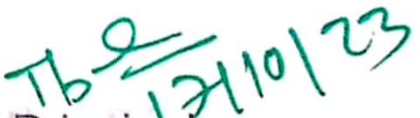
Principal
Nilamani Mahavidyalaya
Rupsa, Balasore.

